# Compiler Design Lab (RCS-652)

# 

# BY:Shreya Srivastava

# UNIV ROLL NO: 1816110198

# BRANCH & YEAR: CSE 3RD YEAR

**FACULTY TEACHER: MR. PRASHANT NARESH**

**Program 1**

**AIM: WAP to check whether the entered string is accepted or not for a given grammar.**

**PROGRAM:**

Strings acceptable by grammar are of form: ab*c(a+b)

#include<stdio.h>

#include<string.h>

#include<stdlib.h>

void main()

{int i,n;

char a[20];

printf("NAME: SHREYA SRIVASTAVA");

printf("\nCLASS: CSE 3D");

printf("\nROLL NO: 1816110198");

printf("\nEnter the term (to check whether it is in form of(ab*c(a+b)): ");

scanf("%s",&a);

n=strlen(a);

if(a[0]=='a'&& (a[n-1]=='a'|| a[n-1]=='b') && a[n-2]=='c')

{

for(i=1;i<n-2;i++)

{if(a[i]=='b')

continue;

else

{printf("STRING IS REJECTED");

exit(0);

}

}

printf("STRING IS ACCEPTED");

}

else

printf("STRING REJECTED");

getch();

}

OUTPUT:

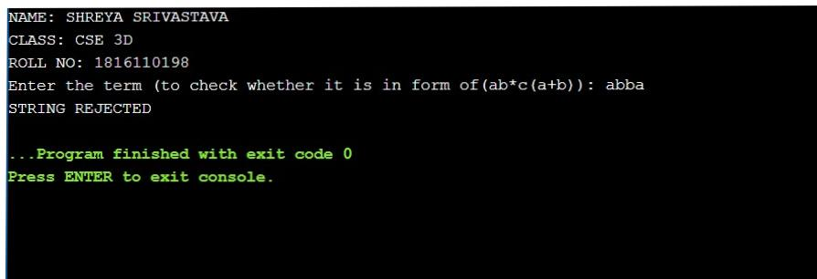

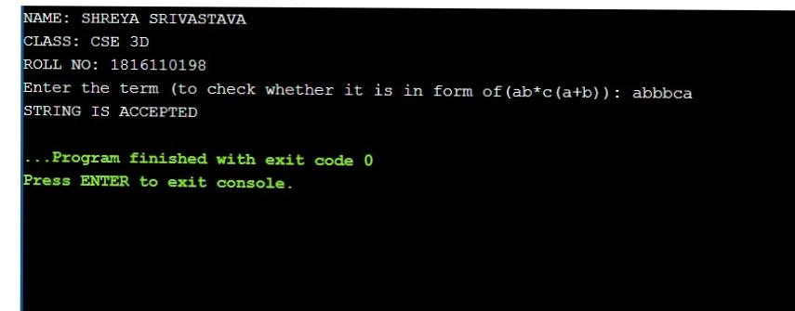

**Program 2**

**AIM: WAP to convert infix expression to postfix expression.**

Expression: A+(C*D)*F

**PROGRAM:**

Top of Form

Bottom of Form

Top of Form

Bottom of Form

|  |  |
| --- | --- |
|  | #include<stdio.h>  #include<conio.h> |
|  | #include<ctype.h> |
|  | char stack[20]; |
|  | int top = -1; |
|  | void push(char x) |
|  | { |
|  | stack[++top] = x; |
|  | } |
|  |  |
|  | char pop() |
|  | { |
|  | if(top == -1) |
|  | return -1; |
|  | else |
|  | return stack[top--]; |
|  | } |
|  |  |
|  | int priority(char x) |
|  | { |
|  | if(x == '(') |
|  | return 0; |
|  | if(x == '+' || x == '-') |
|  | return 1; |
|  | if(x == '*' || x == '/') |
|  | return 2; |
|  | } |
|  |  |
|  | void main() |
|  | {  clrscr(); |
|  | char exp[20]; |
|  | char *e, x; |
|  | printf("\nEnter the infix string : "); |
|  | scanf("%s",exp); |
|  | e = exp;  printf("\nPOSTFIX STRING: "); |
|  | while(*e != '\0') |
|  | { |
|  | if(isalnum(*e)) |
|  | printf("%c",*e); |
|  | else if(*e == '(') |
|  | push(*e); |
|  | else if(*e == ')') |
|  | { |
|  | while((x = pop()) != '(') |
|  | printf("%c", x); |
|  | } |
|  | else |
|  | { |
|  | while(priority(stack[top]) >= priority(*e)) |
|  | printf("%c",pop()); |
|  | push(*e); |
|  | } |
|  | e++; |
|  | } |
|  | while(top != -1) |
|  | { |
|  | printf("%c",pop()); |
|  | }  printf("\n"); |
|  | } |

OUTPUT:

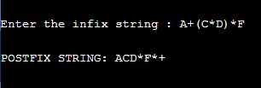

**Program 3**

**AIM: WAP to convert infix expression to prefix expression.**

**PROGRAM:**

#include<stdio.h>

#include<conio.h>

#include<string.h>

char str1[]="A+(C*D)*F";

char str[]="F*(D*C)+A";

char stack[10];

int top=-1;

void push(char s)

{

top=top+1;

stack[top]=s;

}

char pop()

{

char item;

item=stack[top];

top--;

return(item);

}

int precede(char c)

{

if(c==47)

return(5);

if(c==42)

return(4);

if(c==43)

return(3);

else

return(2);

}

void main()

{

char prefix[10];

int l, i=0, j=0;

char s, temp;

printf("INFIX STRING: ");

puts(str);

l=strlen(str);

push('#');

while(i<l)

{

s=str[i];

switch(s)

{

case '(':

push(s);

break;

case ')':

temp=pop();

while(temp!='(')

{

prefix[j]=temp;

j++;

temp=pop();

}

break;

case '+':

case '-':

case '*':

case '/':

while(precede(stack[top])>=precede(s))

{

temp=pop();

prefix[j]=temp;

j++;

}

push(s);

break;

default:

prefix[j++]=s;

break;

}

i++;

}

while(top>0)

{

temp=pop();

prefix[j++]=temp;

}

prefix[j++]='\0';

printf("\nPREFIX STRING: ");

for(i=6;i>=0;i--)

printf("%c", prefix[i]);

getch();

}

**OUTPUT:**



**Program 4**

**AIM: WAP to find the no. of tokens and list them according to their category in an expression (given/entered)**

Eg: a= b+c*23-56^2

**PROGRAM:**

#include<stdio.h>

#include<conio.h>

#include<ctype.h>

int con=0, var=0, op=0;

void check(char c)

{

if(isalpha(c))

var++;

if(c==47||c==42||c==43||c==45||c==61||c==94)

op++;

}

void main()

{

clrscr();

char str[13];

char c;

printf("\nENTER STRING: ");

scanf("%s", &str);

for(int i=0; i<13; i++)

{

c=str[i];

check(c);

}

for(int i=0; i<13; i++)

{

if(isdigit(str[i])&&isdigit(str[i+1]))

{

i=i+2;

con++;

}

else if(isdigit(str[i]))

con++;

}

printf("\n Operators: %d \nVariables: %d \nConstants: %d" , op, var, con);

printf("\nTotal tokens=%d", op+var+con);

getch();

}

OUTPUT:

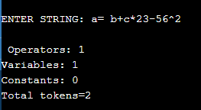

**Program 5**

**AIM: WAP to construct an NFA from a regular expression (given) and display the transition table of NFA constructed.**

1. What is FSM.
2. What is transition diagram.
3. What is E transition.
4. What is Thomsson rule.

Given regular expression: (a/b)*

**PROGRAM:**

#include<iostream>

#include<conio.h>

#include<stdio.h>

#include<string.h>

void main()

{

clrscr();

char s[10];

int n,init=0,fin=1;

cout<<"ENTER R.E : \n”;

gets(s);

n=strlen(s);

for(int i=0;i<n;i++)

{

if(s[i]=='*')

fin+=2;

if(s[i]=='.')

fin+=1;

if(s[i]=='/')

fin+=4;

}

char c=238;

i=0;

int ch;

if(s[0]>=97&&s[0]<=122)

ch=1;

if(s[0]=='('&&s[4]==')')

ch=2;

switch(ch)

{

case 1:

if(s[i+1]=='/')

{

if(s[i+2]>=97 && s[i+2]<=122)

{

cout<<"\n"<<init+2<<"--"<<s[i]<<"-->"<<init+3;

cout<<"\n"<<init+4<<"--"<<s[i+2]<<"-->"<<init+5;

goto pt1;

}

}

case 2:

if(s[i+1]>=97 && s[i+1]<=122)

if(s[i+2]=='/')

{

if(s[i+3]>=97 && s[i+3]<=122)

{

cout<<"\n"<<init+2<<"--"<<s[i+1]<<"-->"<<init+3;

cout<<"\n"<<init+4<<"--"<<s[i+3]<<"-->"<<init+5;

if(s[i+5]=='*')

{

goto pt;

}

else

goto pt1;

}

}

}

pt:

cout<<"\n"<<init<<"--"<<c<<"-->"<<init+1;

cout<<"\n"<<init<<"--"<<c<<"-->"<<fin;

pt1:

cout<<"\n"<<init+1<<"--"<<c<<"-->"<<init+2;

cout<<"\n"<<init+1<<"--"<<c<<"-->"<<init+4;

cout<<"\n"<<init+3<<"--"<<c<<"-->"<<init+6;

cout<<"\n"<<init+5<<"--"<<c<<"-->"<<init+6;

cout<<"\n"<<init+6<<"--"<<c<<"-->"<<init+1;

cout<<"\n"<<init+6<<"--"<<c<<"-->"<<fin;

getch();

}

**OUTPUT:**

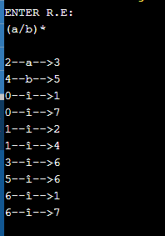

**Program 6**

**AIM: WAP to compute LEADING and TRAILING sets of a grammar(given).**

**Grammar: E🡪 E+T | T**

**T🡪 T*F | F**

**F🡪 (E) | id**

**PROGRAM:**

#include <iostream>

#include <string.h>

using namespace std;

int nt, t, top = 0;

char s[50], NT[10], T[10], st[50], l[10][10], tr[50][50];

int searchnt(char a)

{

int count = -1, i;

for (i = 0; i < nt; i++)

{

if (NT[i] == a)

return i;

}

return count;

}

int searchter(char a)

{

int count = -1, i;

for (i = 0; i < t; i++)

{

if (T[i] == a)

return i;

}

return count;

}

void push(char a)

{

s[top] = a;

top++;

}

char pop()

{

top--;

return s[top];

}

void installl(int a, int b)

{

if (l[a][b] == 'f')

{

l[a][b] = 't';

push(T[b]);

push(NT[a]);

}

}

void installt(int a, int b)

{

if (tr[a][b] == 'f')

{

tr[a][b] = 't';

push(T[b]);

push(NT[a]);

}

}

int main()

{

int i, s, k, j, n;

char pr[30][30], b, c;

cout << "Enter the no of productions:";

cin >> n;

cout << "Enter the productions\n";

for (i = 0; i < n; i++)

cin >> pr[i];

nt = 0;

t = 0;

for (i = 0; i < n; i++)

{

if ((searchnt(pr[i][0])) == -1)

NT[nt++] = pr[i][0];

}

for (i = 0; i < n; i++)

{

for (j = 3; j < strlen(pr[i]); j++)

{

if (searchnt(pr[i][j]) == -1)

{

if (searchter(pr[i][j]) == -1)

T[t++] = pr[i][j];

}

}

}

for (i = 0; i < nt; i++)

{

for (j = 0; j < t; j++)

l[i][j] = 'f';

}

for (i = 0; i < nt; i++)

{

for (j = 0; j < t; j++)

tr[i][j] = 'f';

}

for (i = 0; i < nt; i++)

{

for (j = 0; j < n; j++)

{

if (NT[(searchnt(pr[j][0]))] == NT[i])

{

if (searchter(pr[j][3]) != -1)

installl(searchnt(pr[j][0]), searchter(pr[j][3]));

else

{

for (k = 3; k < strlen(pr[j]); k++)

{

if (searchnt(pr[j][k]) == -1)

{

installl(searchnt(pr[j][0]), searchter(pr[j][k]));

break;

}

}

}

}

}

}

while (top != 0)

{

b = pop();

c = pop();

for (s = 0; s < n; s++)

{

if (pr[s][3] == b)

installl(searchnt(pr[s][0]), searchter(c));

}

}

for (i = 0; i < nt; i++)

{

cout << "Leading[" << NT[i] << "]"

<< "\t{";

for (j = 0; j < t; j++)

{

if (l[i][j] == 't')

cout << T[j] << ",";

}

cout << "}\n";

}

top = 0;

for (i = 0; i < nt; i++)

{

for (j = 0; j < n; j++)

{

if (NT[searchnt(pr[j][0])] == NT[i])

{

if (searchter(pr[j][strlen(pr[j]) - 1]) != -1)

installt(searchnt(pr[j][0]), searchter(pr[j][strlen(pr[j]) - 1]));

else

{

for (k = (strlen(pr[j]) - 1); k >= 3; k--)

{

if (searchnt(pr[j][k]) == -1)

{

installt(searchnt(pr[j][0]), searchter(pr[j][k]));

break;

}

}

}

}

}

}

while (top != 0)

{

b = pop();

c = pop();

for (s = 0; s < n; s++)

{

if (pr[s][3] == b)

installt(searchnt(pr[s][0]), searchter(c));

}

}

for (i = 0; i < nt; i++)

{

cout << "Trailing[" << NT[i] << "]"

<< "\t{";

for (j = 0; j < t; j++)

{

if (tr[i][j] == 't')

cout << T[j] << ",";

}

cout << "}\n";

}

return 0;

}

OUTPUT :

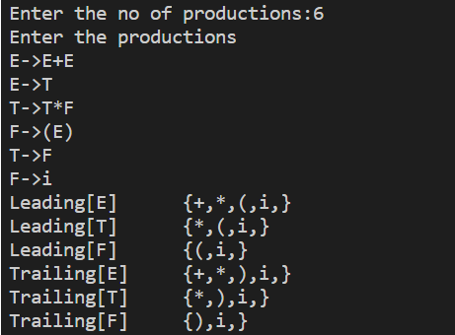

**Program 7**

**AIM: WAP to calculate FIRST and FOLLOW.**

**PROGRAM:**

FIRST:

#include<stdio.h>

#include<ctype.h>

int count,n=0;

char prodn[10][10],first[10];

void First(char ch)

{int j;

/*if(!isupper(ch))

{

first[n++]=ch;

}*/

for(j=0;j<count;j++)

{

if(prodn[j][0]==ch)

{if(prodn[j][2]=='$')

{

first[n++]='$';

}

else if(islower(prodn[j][2]))

{

first[n++]=prodn[j][2];

}

else

First(prodn[j][2]);

}

}

}

void main()

{int i,choice;

char c,ch;

printf("Enter the no of productions: ");

scanf("%d",&count);

printf("\nEnter %d the production, epsilon=$ : ",count);

for(i=0;i<count;i++)

scanf("%s%c",prodn[i],&ch);

do{

n=0;

printf("Element :");

scanf("%c",&c);

First(c);

printf("\nFIRST(%c)={",c);

for(i=0;i<n;i++)

{printf("%c,",first[i]);

}

printf("}\n");

printf("Press 1 to continue");

scanf("%d%c",&choice,&ch);

}while(choice==1);

}

OUTPUT:

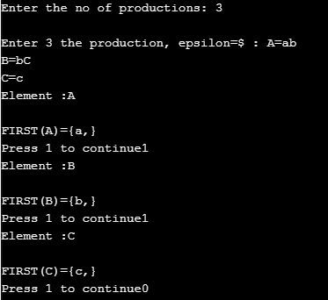

FOLLOW:

#include<stdio.h>

#include<string.h>

int n,m=0,p,i=0,j=0;

char prodn[10][10],follow[10];

void Follow(char c)

{

if(prodn[0][0]==c)

follow[m++]='$';

for(i=0;i<n;i++)

{

for(j=2;j<strlen(prodn[i]);j++)

{

if(prodn[i][j]==c)

{

if(prodn[i][j+1]!='\0')

first(prodn[i][j+1]);

if(prodn[i][j+1]=='\0'&&c!=prodn[i][0])

Follow(prodn[i][0]);

}

}

}

}

void first(char c)

{

int k;

if(!(isupper(c)))

follow[m++]=c;

for(k=0;k<n;k++)

{

if(prodn[k][0]==c)

{

if(prodn[k][2]=='$')

Follow(prodn[i][0]);

else if(islower(prodn[k][2]))

follow[m++]=prodn[k][2];

else first(prodn[k][2]);

}

}

}

int main()

{

int i,z;

char c,ch;

printf("Enter the no.of productions:");

scanf("%d",&n);

printf("Enter the productions(epsilon=$):\n");

for(i=0;i<n;i++)

scanf("%s%c",prodn[i],&ch);

do

{

m=0;

printf("Enter the element whose FOLLOW is to be found:");

scanf("%c",&c);

Follow(c);

printf("FOLLOW(%c) = { ",c);

for(i=0;i<m;i++)

printf("%c ",follow[i]);

printf(" }\n");

printf("Do you want to continue?(press 1 to continue)");

scanf("%d%c",&z,&ch);

}

while(z==1);

}

OUTPUT:

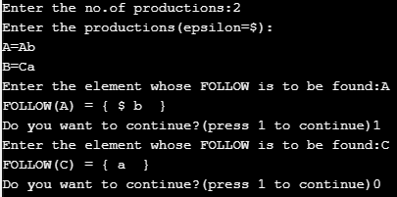

**Program 8**

**AIM: WAP in C to check whether the Grammar is Left-recursive and remove left recursion.**

**PROGRAM:**

#include <stdio.h>

#include <string.h>

#define SIZE 10

int main()

{

char non_terminal;

char beta, alpha;

int num;

char production[10][SIZE];

int index = 3; /* starting of the string following "->" */

printf("Enter Number of Production : ");

scanf("%d", &num);

printf("Enter the grammar as E->E-A :\n");

for (int i = 0; i < num; i++)

{

scanf("%s", production[i]);

}

for (int i = 0; i < num; i++)

{

printf("\nGRAMMAR : : : %s", production[i]);

non_terminal = production[i][0];

if (non_terminal == production[i][index])

{

alpha = production[i][index + 1];

printf(" is left recursive.\n");

while (production[i][index] != 0 && production[i][index] != '|')

index++;

if (production[i][index] != 0)

{

beta = production[i][index + 1];

printf("Grammar without left recursion:\n");

printf("%c->%c%c\'", non_terminal, beta, non_terminal);

printf("\n%c\'->%c%c\'|E\n", non_terminal, alpha, non_terminal);

}

else

printf(" can't be reduced\n");

}

else

printf(" is not left recursive.\n");

index = 3;

}

}

OUTPUT:

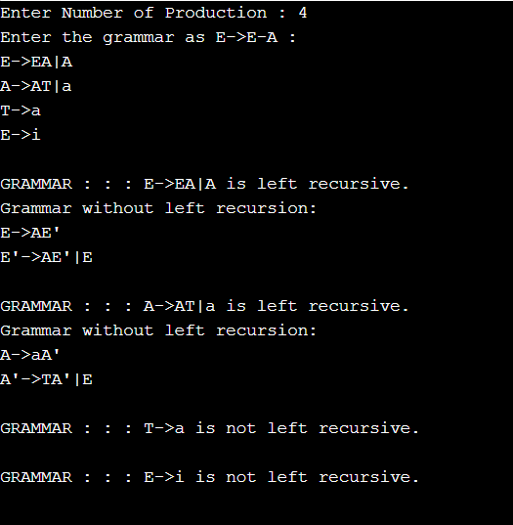

**Prgramm-9**

**AIM: WAP in C to draw a SLR parsing table for a given grammar**

**PROGRAM:**

#include <iostream>

#include <string.h>

#include <stdlib.h>

#include <stdio.h>

using namespace std;

char terminals[100] = {};

int no_t;

char non_terminals[100] = {};

int no_nt;

char goto_table[100][100];

char reduce[20][20];

char follow[20][20];

char fo_co[20][20];

char first[20][20];

struct state

{

int prod_count;

char prod[100][100] = {{}};

};

void add_dots(struct state *I)

{

for (int i = 0; i < I->prod_count; i++)

{

for (int j = 99; j > 3; j--)

I->prod[i][j] = I->prod[i][j - 1];

I->prod[i][3] = '.';

}

}

void augument(struct state *S, struct state *I)

{

if (I->prod[0][0] == 'S')

strcpy(S->prod[0], "Z->.S");

else

{

strcpy(S->prod[0], "S->.");

S->prod[0][4] = I->prod[0][0];

}

S->prod_count++;

}

void get_prods(struct state *I)

{

cout << "Enter the number of productions:\n";

cin >> I->prod_count;

cout << "Enter the number of non terminals:" << endl;

cin >> no_nt;

cout << "Enter the non terminals one by one:" << endl;

for (int i = 0; i < no_nt; i++)

cin >> non_terminals[i];

cout << "Enter the number of terminals:" << endl;

cin >> no_t;

cout << "Enter the terminals (single lettered) one by one:" << endl;

for (int i = 0; i < no_t; i++)

cin >> terminals[i];

cout << "Enter the productions one by one in form (S->ABc):\n";

for (int i = 0; i < I->prod_count; i++)

{

cin >> I->prod[i];

}

}

bool is_non_terminal(char a)

{

if (a >= 'A' && a <= 'Z')

return true;

else

return false;

}

bool in_state(struct state *I, char *a)

{

for (int i = 0; i < I->prod_count; i++)

{

if (!strcmp(I->prod[i], a))

return true;

}

return false;

}

char char_after_dot(char a[100])

{

char b;

for (int i = 0; i < strlen(a); i++)

if (a[i] == '.')

{

b = a[i + 1];

return b;

}

}

char *move_dot(char b[100], int len)

{

char a[100] = {};

strcpy(a, b);

for (int i = 0; i < len; i++)

{

if (a[i] == '.')

{

swap(a[i], a[i + 1]);

break;

}

}

return &a[0];

}

bool same_state(struct state *I0, struct state *I)

{

if (I0->prod_count != I->prod_count)

return false;

for (int i = 0; i < I0->prod_count; i++)

{

int flag = 0;

for (int j = 0; j < I->prod_count; j++)

if (strcmp(I0->prod[i], I->prod[j]) == 0)

flag = 1;

if (flag == 0)

return false;

}

return true;

}

void closure(struct state *I, struct state *I0)

{

char a = {};

for (int i = 0; i < I0->prod_count; i++)

{

a = char_after_dot(I0->prod[i]);

if (is_non_terminal(a))

{

for (int j = 0; j < I->prod_count; j++)

{

if (I->prod[j][0] == a)

{

if (!in_state(I0, I->prod[j]))

{

strcpy(I0->prod[I0->prod_count], I->prod[j]);

I0->prod_count++;

}

}

}

}

}

}

void goto_state(struct state *I, struct state *S, char a)

{

int time = 1;

for (int i = 0; i < I->prod_count; i++)

{

if (char_after_dot(I->prod[i]) == a)

{

if (time == 1)

{

time++;

}

strcpy(S->prod[S->prod_count], move_dot(I->prod[i], strlen(I->prod[i])));

S->prod_count++;

}

}

}

void print_prods(struct state *I)

{

for (int i = 0; i < I->prod_count; i++)

printf("%s\n", I->prod[i]);

cout << endl;

}

bool in_array(char a[20], char b)

{

for (int i = 0; i < strlen(a); i++)

if (a[i] == b)

return true;

return false;

}

char *chars_after_dots(struct state *I)

{

char a[20] = {};

for (int i = 0; i < I->prod_count; i++)

{

if (!in_array(a, char_after_dot(I->prod[i])))

{

a[strlen(a)] = char_after_dot(I->prod[i]);

}

}

return &a[0];

}

void cleanup_prods(struct state *I)

{

char a[100] = {};

for (int i = 0; i < I->prod_count; i++)

strcpy(I->prod[i], a);

I->prod_count = 0;

}

int return_index(char a)

{

for (int i = 0; i < no_t; i++)

if (terminals[i] == a)

return i;

for (int i = 0; i < no_nt; i++)

if (non_terminals[i] == a)

return no_t + i;

}

void print_shift_table(int state_count)

{

cout << endl

<< "********Shift Actions*********" << endl

<< endl;

cout << "\t";

for (int i = 0; i < no_t; i++)

cout << terminals[i] << "\t";

for (int i = 0; i < no_nt; i++)

cout << non_terminals[i] << "\t";

cout << endl;

for (int i = 0; i < state_count; i++)

{

int arr[no_nt + no_t] = {-1};

for (int j = 0; j < state_count; j++)

{

if (goto_table[i][j] != '~')

{

arr[return_index(goto_table[i][j])] = j;

}

}

cout << "I" << i << "\t";

for (int j = 0; j < no_nt + no_t; j++)

{

if (i == 1 && j == no_t - 1)

cout << "ACC"

<< "\t";

if (arr[j] == -1 || arr[j] == 0)

cout << "\t";

else

{

if (j < no_t)

cout << "S" << arr[j] << "\t";

else

cout << arr[j] << "\t";

}

}

cout << "\n";

}

}

int get_index(char c, char *a)

{

for (int i = 0; i < strlen(a); i++)

if (a[i] == c)

return i;

}

void add_dot_at_end(struct state *I)

{

for (int i = 0; i < I->prod_count; i++)

{

strcat(I->prod[i], ".");

}

}

void add_to_first(int n, char b)

{

for (int i = 0; i < strlen(first[n]); i++)

if (first[n][i] == b)

return;

first[n][strlen(first[n])] = b;

}

void add_to_first(int m, int n)

{

for (int i = 0; i < strlen(first[n]); i++)

{

int flag = 0;

for (int j = 0; j < strlen(first[m]); j++)

{

if (first[n][i] == first[m][j])

flag = 1;

}

if (flag == 0)

add_to_first(m, first[n][i]);

}

}

void add_to_follow(int n, char b)

{

for (int i = 0; i < strlen(follow[n]); i++)

if (follow[n][i] == b)

return;

follow[n][strlen(follow[n])] = b;

}

void add_to_follow(int m, int n)

{

for (int i = 0; i < strlen(follow[n]); i++)

{

int flag = 0;

for (int j = 0; j < strlen(follow[m]); j++)

{

if (follow[n][i] == follow[m][j])

flag = 1;

}

if (flag == 0)

add_to_follow(m, follow[n][i]);

}

}

void add_to_follow_first(int m, int n)

{

for (int i = 0; i < strlen(first[n]); i++)

{

int flag = 0;

for (int j = 0; j < strlen(follow[m]); j++)

{

if (first[n][i] == follow[m][j])

flag = 1;

}

if (flag == 0)

add_to_follow(m, first[n][i]);

}

}

void find_first(struct state *I)

{

for (int i = 0; i < no_nt; i++)

{

for (int j = 0; j < I->prod_count; j++)

{

if (I->prod[j][0] == non_terminals[i])

{

if (!is_non_terminal(I->prod[j][3]))

{

add_to_first(i, I->prod[j][3]);

}

}

}

}

}

void find_follow(struct state *I)

{

for (int i = 0; i < no_nt; i++)

{

for (int j = 0; j < I->prod_count; j++)

{

for (int k = 3; k < strlen(I->prod[j]); k++)

{

if (I->prod[j][k] == non_terminals[i])

{

if (I->prod[j][k + 1] != '\0')

{

if (!is_non_terminal(I->prod[j][k + 1]))

{

add_to_follow(i, I->prod[j][k + 1]);

}

}

}

}

}

}

}

int get_index(int *arr, int n)

{

for (int i = 0; i < no_t; i++)

{

if (arr[i] == n)

return i;

}

return -1;

}

void print_reduce_table(int state_count, int *no_re, struct state *temp1)

{

cout << "**********Reduce actions**********" << endl

<< endl;

cout << "\t";

int arr[temp1->prod_count][no_t] = {-1};

for (int i = 0; i < no_t; i++)

{

cout << terminals[i] << "\t";

}

cout << endl;

for (int i = 0; i < temp1->prod_count; i++)

{

int n = no_re[i];

for (int j = 0; j < strlen(follow[return_index(temp1->prod[i][0]) - no_t]); j++)

{

for (int k = 0; k < no_t; k++)

{

if (follow[return_index(temp1->prod[i][0]) - no_t][j] == terminals[k])

arr[i][k] = i + 1;

}

}

cout << "I" << n << "\t";

for (int j = 0; j < no_t; j++)

{

if (arr[i][j] != -1 && arr[i][j] != 0 && arr[i][j] < state_count)

cout << "R" << arr[i][j] << "\t";

else

cout << "\t";

}

cout << endl;

}

}

int main()

{

struct state init;

struct state temp;

struct state temp1;

int state_count = 1;

get_prods(&init);

temp = init;

temp1 = temp;

add_dots(&init);

for (int i = 0; i < 100; i++)

for (int j = 0; j < 100; j++)

goto_table[i][j] = '~';

struct state I[50];

augument(&I[0], &init);

closure(&init, &I[0]);

cout << "\nI0:\n";

print_prods(&I[0]);

char characters[20] = {};

for (int i = 0; i < state_count; i++)

{

char characters[20] = {};

for (int z = 0; z < I[i].prod_count; z++)

if (!in_array(characters, char_after_dot(I[i].prod[z])))

characters[strlen(characters)] = char_after_dot(I[i].prod[z]);

for (int j = 0; j < strlen(characters); j++)

{

goto_state(&I[i], &I[state_count], characters[j]);

closure(&init, &I[state_count]);

int flag = 0;

for (int k = 0; k < state_count - 1; k++)

{

if (same_state(&I[k], &I[state_count]))

{

cleanup_prods(&I[state_count]);

flag = 1;

cout << "I" << i << " on reading the symbol " << characters[j] << " goes to I" << k << ".\n";

goto_table[i][k] = characters[j];

;

break;

}

}

if (flag == 0)

{

state_count++;

cout << "I" << i << " on reading the symbol " << characters[j] << " goes to I" << state_count - 1 << ":\n";

goto_table[i][state_count - 1] = characters[j];

print_prods(&I[state_count - 1]);

}

}

}

int no_re[temp.prod_count] = {-1};

terminals[no_t] = '$';

no_t++;

add_dot_at_end(&temp1);

for (int i = 0; i < state_count; i++)

{

for (int j = 0; j < I[i].prod_count; j++)

for (int k = 0; k < temp1.prod_count; k++)

if (in_state(&I[i], temp1.prod[k]))

no_re[k] = i;

}

find_first(&temp);

for (int l = 0; l < no_nt; l++)

{

for (int i = 0; i < temp.prod_count; i++)

{

if (is_non_terminal(temp.prod[i][3]))

{

add_to_first(return_index(temp.prod[i][0]) - no_t, return_index(temp.prod[i][3]) - no_t);

}

}

}

find_follow(&temp);

add_to_follow(0, '$');

for (int l = 0; l < no_nt; l++)

{

for (int i = 0; i < temp.prod_count; i++)

{

for (int k = 3; k < strlen(temp.prod[i]); k++)

{

if (temp.prod[i][k] == non_terminals[l])

{

if (is_non_terminal(temp.prod[i][k + 1]))

{

add_to_follow_first(l, return_index(temp.prod[i][k + 1]) - no_t);

}

if (temp.prod[i][k + 1] == '\0')

add_to_follow(l, return_index(temp.prod[i][0]) - no_t);

}

}

}

}

print_shift_table(state_count);

cout << endl

<< endl;

print_reduce_table(state_count, &no_re[0], &temp1);

}

OUTPUT:

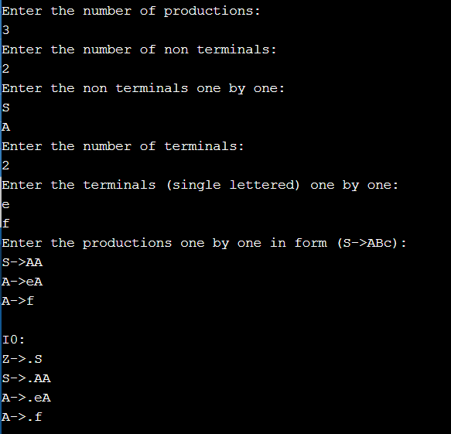

**Program 10**

**AIM: WAP in C to draw an operator precedence parsing table for the given grammar**

**PROGRAM:**

#include<stdio.h>

#include<conio.h>

#include<string.h>

void main()

{

char stack[20],ip[20],opt[10][10][1],ter[10];

int i,j,k,n,top=0,col,row;

for(i=0;i<10;i++)

{

stack[i]=NULL; ip[i]=NULL;

for(j=0;j<10;j++)

{

opt[i][j][1]=NULL;

}

}

printf("Enter the no.of terminals:");

scanf("%d",&n);

printf("\nEnter the terminals:");

scanf("%s",ter);

printf("\nEnter the table values:\n");

for(i=0;i<n;i++)

{

for(j=0;j<n;j++)

{

printf("Enter the value for %c %c:",ter[i],ter[j]);

scanf("%s",opt[i][j]);

}

}

printf("\nOPERATOR PRECEDENCE TABLE:\n");

for(i=0;i<n;i++){printf("\t%c",ter[i]);}

printf("\n");

for(i=0;i<n;i++){printf("\n%c",ter[i]);

for(j=0;j<n;j++){printf("\t%c",opt[i][j][0]);}}

stack[top]='$';

printf("\nEnter the input string:");

scanf("%s",ip);

i=0;

printf("\nSTACK\t\t\tINPUT STRING\t\t\tACTION\n");

printf("\n%s\t\t\t%s\t\t\t",stack,ip);

while(i<=strlen(ip))

{

for(k=0;k<n;k++)

{

if(stack[top]==ter[k])

col=k;

if(ip[i]==ter[k])

row=k;

}

if((stack[top]=='$')&&(ip[i]=='$')){

printf("String is accepted");

break;}

else if((opt[col][row][0]=='<') ||(opt[col][row][0]=='='))

{ stack[++top]=opt[col][row][0];

stack[++top]=ip[i];

printf("Shift %c",ip[i]);

i++;

}

else

{

if(opt[col][row][0]=='>')

{

while(stack[top]!='<'){--top;}

top=top-1;

printf("Reduce");

}

else

{

printf("\nString is not accepted");

break;

}

}

printf("\n");

for(k=0;k<=top;k++)

{

printf("%c",stack[k]);

}

printf("\t\t\t");

for(k=i;k<strlen(ip);k++){

printf("%c",ip[k]);

}

printf("\t\t\t");

}

getch();

}

OUTPUT:

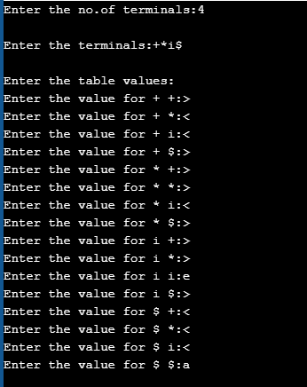 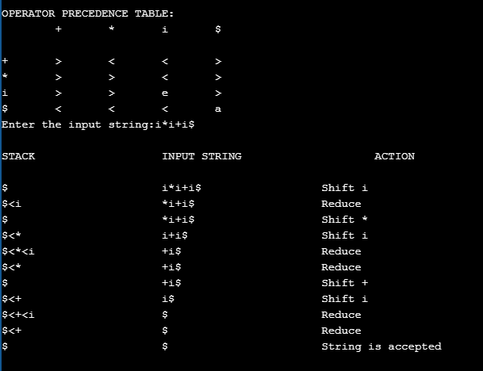

**Program-11**

**AIM: WAP in C to draw a LL parsing table for a given grammar**

**PROGRAM:**

#include <stdio.h>

#include <ctype.h>

#include <string.h>

#include <stdlib.h>

void followfirst(char, int, int);

void findfirst(char, int, int);

void follow(char c);

int count, n = 0;

char calc_first[10][100];

char calc_follow[10][100];

int m = 0;

char production[10][10], first[10];

char f[10];

int k;

char ck;

int e;

int main(int argc, char **argv)

{

int jm = 0;

int km = 0;

int i, choice;

char c, ch;

printf("How many productions ? :");

scanf("%d", &count);

printf("\nEnter %d productions in form A=B where A and B are grammar symbols :\n\n", count);

for (i = 0; i < count; i++)

{

scanf("%s%c", production[i], &ch);

}

int kay;

char done[count];

int ptr = -1;

for (k = 0; k < count; k++)

{

for (kay = 0; kay < 100; kay++)

{

calc_first[k][kay] = '!';

}

}

int point1 = 0, point2, xxx;

for (k = 0; k < count; k++)

{

c = production[k][0];

point2 = 0;

xxx = 0;

for (kay = 0; kay <= ptr; kay++)

if (c == done[kay])

xxx = 1;

if (xxx == 1)

continue;

findfirst(c, 0, 0);

ptr += 1;

done[ptr] = c;

printf("\n First(%c)= { ", c);

calc_first[point1][point2++] = c;

for (i = 0 + jm; i < n; i++)

{

int lark = 0, chk = 0;

for (lark = 0; lark < point2; lark++)

{

if (first[i] == calc_first[point1][lark])

{

chk = 1;

break;

}

}

if (chk == 0)

{

printf("%c, ", first[i]);

calc_first[point1][point2++] = first[i];

}

}

printf("}\n");

jm = n;

point1++;

}

printf("\n");

printf("-----------------------------------------------\n\n");

char donee[count];

ptr = -1;

for (k = 0; k < count; k++)

{

for (kay = 0; kay < 100; kay++)

{

calc_follow[k][kay] = '!';

}

}

point1 = 0;

int land = 0;

for (e = 0; e < count; e++)

{

ck = production[e][0];

point2 = 0;

xxx = 0;

for (kay = 0; kay <= ptr; kay++)

if (ck == donee[kay])

xxx = 1;

if (xxx == 1)

continue;

land += 1;

follow(ck);

ptr += 1;

donee[ptr] = ck;

printf(" Follow(%c) = { ", ck);

calc_follow[point1][point2++] = ck;

for (i = 0 + km; i < m; i++)

{

int lark = 0, chk = 0;

for (lark = 0; lark < point2; lark++)

{

if (f[i] == calc_follow[point1][lark])

{

chk = 1;

break;

}

}

if (chk == 0)

{

printf("%c, ", f[i]);

calc_follow[point1][point2++] = f[i];

}

}

printf(" }\n\n");

km = m;

point1++;

}

char ter[10];

for (k = 0; k < 10; k++)

{

ter[k] = '!';

}

int ap, vp, sid = 0;

for (k = 0; k < count; k++)

{

for (kay = 0; kay < count; kay++)

{

if (!isupper(production[k][kay]) && production[k][kay] != '#' && production[k][kay] != '=' && production[k][kay] != '\0')

{

vp = 0;

for (ap = 0; ap < sid; ap++)

{

if (production[k][kay] == ter[ap])

{

vp = 1;

break;

}

}

if (vp == 0)

{

ter[sid] = production[k][kay];

sid++;

}

}

}

}

ter[sid] = '$';

sid++;

printf("\n\t\t\t\t\t\t\t The LL(1) Parsing Table for the above grammer :-");

printf("\n\t\t\t\t\t\t\t^^^^^^^^^^^^^^^^^^^^^^^^^^^^^^^^^^^^^^^^^^^^^^^^^^\n");

printf("\n\t\t\t=====================================================================================================================\n");

printf("\t\t\t\t|\t");

for (ap = 0; ap < sid; ap++)

{

printf("%c\t\t", ter[ap]);

}

printf("\n\t\t\t=====================================================================================================================\n");

char first_prod[count][sid];

for (ap = 0; ap < count; ap++)

{

int destiny = 0;

k = 2;

int ct = 0;

char tem[100];

while (production[ap][k] != '\0')

{

if (!isupper(production[ap][k]))

{

tem[ct++] = production[ap][k];

tem[ct++] = '_';

tem[ct++] = '\0';

k++;

break;

}

else

{

int zap = 0;

int tuna = 0;

for (zap = 0; zap < count; zap++)

{

if (calc_first[zap][0] == production[ap][k])

{

for (tuna = 1; tuna < 100; tuna++)

{

if (calc_first[zap][tuna] != '!')

{

tem[ct++] = calc_first[zap][tuna];

}

else

break;

}

break;

}

}

tem[ct++] = '_';

}

k++;

}

int zap = 0, tuna;

for (tuna = 0; tuna < ct; tuna++)

{

if (tem[tuna] == '#')

{

zap = 1;

}

else if (tem[tuna] == '_')

{

if (zap == 1)

{

zap = 0;

}

else

break;

}

else

{

first_prod[ap][destiny++] = tem[tuna];

}

}

}

char table[land][sid + 1];

ptr = -1;

for (ap = 0; ap < land; ap++)

{

for (kay = 0; kay < (sid + 1); kay++)

{

table[ap][kay] = '!';

}

}

for (ap = 0; ap < count; ap++)

{

ck = production[ap][0];

xxx = 0;

for (kay = 0; kay <= ptr; kay++)

if (ck == table[kay][0])

xxx = 1;

if (xxx == 1)

continue;

else

{

ptr = ptr + 1;

table[ptr][0] = ck;

}

}

for (ap = 0; ap < count; ap++)

{

int tuna = 0;

while (first_prod[ap][tuna] != '\0')

{

int to, ni = 0;

for (to = 0; to < sid; to++)

{

if (first_prod[ap][tuna] == ter[to])

{

ni = 1;

}

}

if (ni == 1)

{

char xz = production[ap][0];

int cz = 0;

while (table[cz][0] != xz)

{

cz = cz + 1;

}

int vz = 0;

while (ter[vz] != first_prod[ap][tuna])

{

vz = vz + 1;

}

table[cz][vz + 1] = (char)(ap + 65);

}

tuna++;

}

}

for (k = 0; k < sid; k++)

{

for (kay = 0; kay < 100; kay++)

{

if (calc_first[k][kay] == '!')

{

break;

}

else if (calc_first[k][kay] == '#')

{

int fz = 1;

while (calc_follow[k][fz] != '!')

{

char xz = production[k][0];

int cz = 0;

while (table[cz][0] != xz)

{

cz = cz + 1;

}

int vz = 0;

while (ter[vz] != calc_follow[k][fz])

{

vz = vz + 1;

}

table[k][vz + 1] = '#';

fz++;

}

break;

}

}

}

for (ap = 0; ap < land; ap++)

{

printf("\t\t\t %c\t|\t", table[ap][0]);

for (kay = 1; kay < (sid + 1); kay++)

{

if (table[ap][kay] == '!')

printf("\t\t");

else if (table[ap][kay] == '#')

printf("%c=#\t\t", table[ap][0]);

else

{

int mum = (int)(table[ap][kay]);

mum -= 65;

printf("%s\t\t", production[mum]);

}

}

printf("\n");

printf("\t\t\t---------------------------------------------------------------------------------------------------------------------");

printf("\n");

}

int j;

printf("\n\nPlease enter the desired INPUT STRING = ");

char input[100];

scanf("%s%c", input, &ch);

printf("\n\t\t\t\t\t===========================================================================\n");

printf("\t\t\t\t\t\tStack\t\t\tInput\t\t\tAction");

printf("\n\t\t\t\t\t===========================================================================\n");

int i_ptr = 0, s_ptr = 1;

char stack[100];

stack[0] = '$';

stack[1] = table[0][0];

while (s_ptr != -1)

{

printf("\t\t\t\t\t\t");

int vamp = 0;

for (vamp = 0; vamp <= s_ptr; vamp++)

{

printf("%c", stack[vamp]);

}

printf("\t\t\t");

vamp = i_ptr;

while (input[vamp] != '\0')

{

printf("%c", input[vamp]);

vamp++;

}

printf("\t\t\t");

char her = input[i_ptr];

char him = stack[s_ptr];

s_ptr--;

if (!isupper(him))

{

if (her == him)

{

i_ptr++;

printf("POP ACTION\n");

}

else

{

printf("\nString Not Accepted by LL(1) Parser !!\n");

exit(0);

}

}

else

{

for (i = 0; i < sid; i++)

{

if (ter[i] == her)

break;

}

char produ[100];

for (j = 0; j < land; j++)

{

if (him == table[j][0])

{

if (table[j][i + 1] == '#')

{

printf("%c=#\n", table[j][0]);

produ[0] = '#';

produ[1] = '\0';

}

else if (table[j][i + 1] != '!')

{

int mum = (int)(table[j][i + 1]);

mum -= 65;

strcpy(produ, production[mum]);

printf("%s\n", produ);

}

else

{

printf("\nString Not Accepted by LL(1) Parser !!\n");

exit(0);

}

}

}

int le = strlen(produ);

le = le - 1;

if (le == 0)

{

continue;

}

for (j = le; j >= 2; j--)

{

s_ptr++;

stack[s_ptr] = produ[j];

}

}

}

printf("\n\t\t\t=======================================================================================================================\n");

if (input[i_ptr] == '\0')

{

printf("\t\t\t\t\t\t\t\tYOUR STRING HAS BEEN ACCEPTED !!\n");

}

else

printf("\n\t\t\t\t\t\t\t\tYOUR STRING HAS BEEN REJECTED !!\n");

printf("\t\t\t=======================================================================================================================\n");

}

void follow(char c)

{

int i, j;

if (production[0][0] == c)

{

f[m++] = '$';

}

for (i = 0; i < 10; i++)

{

for (j = 2; j < 10; j++)

{

if (production[i][j] == c)

{

if (production[i][j + 1] != '\0')

{

followfirst(production[i][j + 1], i, (j + 2));

}

if (production[i][j + 1] == '\0' && c != production[i][0])

{

follow(production[i][0]);

}

}

}

}

}

void findfirst(char c, int q1, int q2)

{

int j;

if (!(isupper(c)))

{

first[n++] = c;

}

for (j = 0; j < count; j++)

{

if (production[j][0] == c)

{

if (production[j][2] == '#')

{

if (production[q1][q2] == '\0')

first[n++] = '#';

else if (production[q1][q2] != '\0' && (q1 != 0 || q2 != 0))

{

findfirst(production[q1][q2], q1, (q2 + 1));

}

else

first[n++] = '#';

}

else if (!isupper(production[j][2]))

{

first[n++] = production[j][2];

}

else

{

findfirst(production[j][2], j, 3);

}

}

}

}

void followfirst(char c, int c1, int c2)

{

int k;

if (!(isupper(c)))

f[m++] = c;

else

{

int i = 0, j = 1;

for (i = 0; i < count; i++)

{

if (calc_first[i][0] == c)

break;

}

while (calc_first[i][j] != '!')

{

if (calc_first[i][j] != '#')

{

f[m++] = calc_first[i][j];

}

else

{

if (production[c1][c2] == '\0')

{

follow(production[c1][0]);

}

else

{

followfirst(production[c1][c2], c1, c2 + 1);

}

}

j++;

}

}

}OUTPUT:

